Chapter 18, Solution 68.

The total energy is

W_{T} = 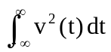

Since v(t) is an even function,

W_{T} = 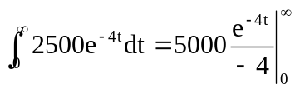 = 1250 J

V(ω) = 50x4/(4 + ω²)

W = 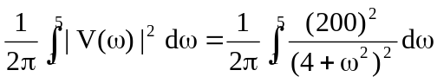

But 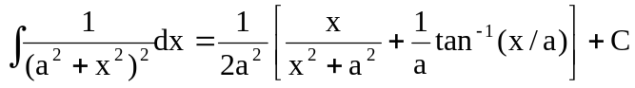

W = 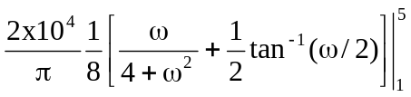

= (2500/π)[(5/29) + 0.5tan⁻¹(5/2) – (1/5) – 0.5tan^{–1}(1/2) = 267.19

W/W_{T} = 267.19/1250 = 0.2137 or 21.37%

